**PRACTICAL TWO**

1. Adobe PDF represents a two dimensional document in a way that allows it to be changed independent of its software, hardware, or operating system; XPS is a document [management](http://www.differencebetween.net/business/difference-between-leadership-and-management/) software that allows the user to view, annotate, convert, sign, and print XPS documents.

2. Adobe PDF uses three technologies to run the PDF format: PostScript, a font embedding system, and a structured storage system; XPS has three feature options: highlight annotations, text annotations, and ink annotations

**PRACTICAL THREE**

1. **Establish a timeline.** Establishing the parameters for when and where your story takes place, and deciding in which order the events of the story happen chronologically, is the best way to organize your story so you can begin bringing it to life.
2. **Identify the key scenes in your story.** A storyboard is meant to give its viewer the gist of how the story will translate to film. The point isn't to try to recreate the entire experience in a flip book, but to demonstrate important key parts that will draw the viewer in.
3. **Decide how detailed to get.** A storyboard can be incredibly detailed, with illustrations depicting every shot. If you’re in the preliminary stages of a feature-length film, you have too much ground to cover to get this detailed just now. However, you might eventually want to break the film down into individual scenes, with a separate storyboard for each one.
4. **Write a description of what each cell will show.** Now that you know what main scenes you want to show, think about how to depict the action in each illustration. Go down your list of scenes and write a description of the most important elements of each one.
5. **Decide what medium to use for your template.** You can draw a basic storyboard template by hand, simply dividing a posterboard into empty frames of the same size using a pencil and a straightedge.
6. **Sketch your thumbnails.** Start bringing the scenes to life by drawing the sketches you mapped out into the template you designed.
7. **Add other important information.** Next to or below each cell, fill in your description of what’s happening in the scene.

PRACTICAL FOUR

Print X1,X2

X2=(-b-d)/(2*a)

X1=(-b+d)/(2*a)

D=sqrt(b*b-4*a*c)

Input a,b,c

PRACTICAL FIVE

**Program Code**

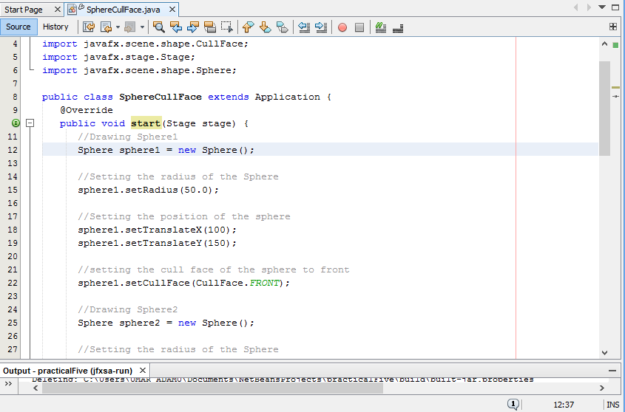

**Program Interface**

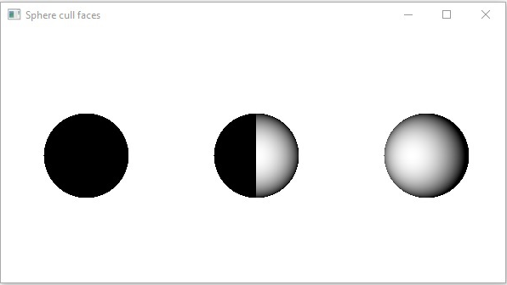

PRACTICAL SIX

**Program Code**

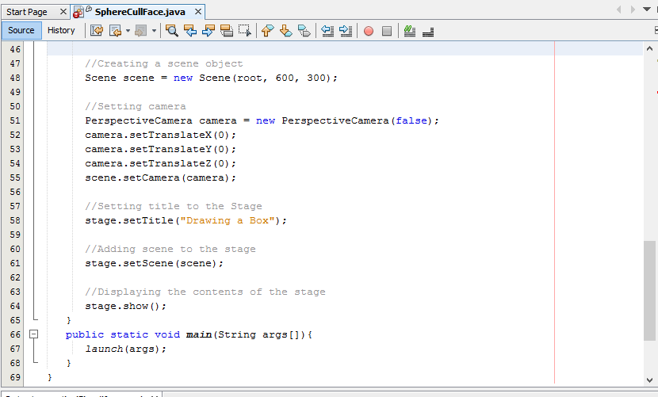

**Program Interface**

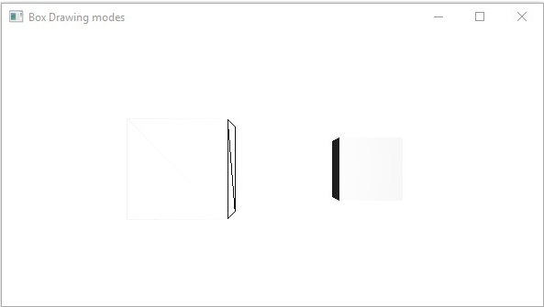

PRACTICAL EIGHT

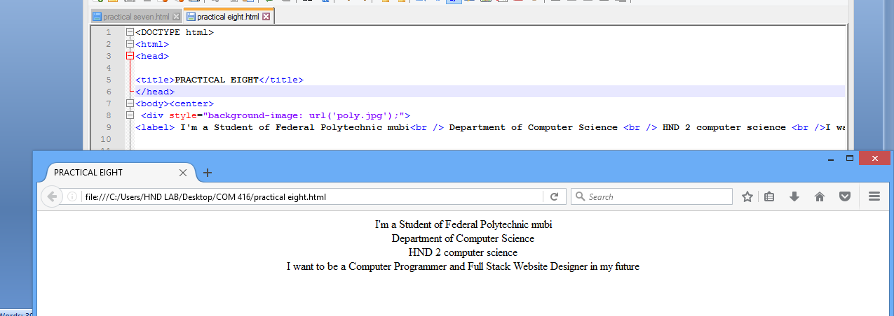

PRACTICAL NINE

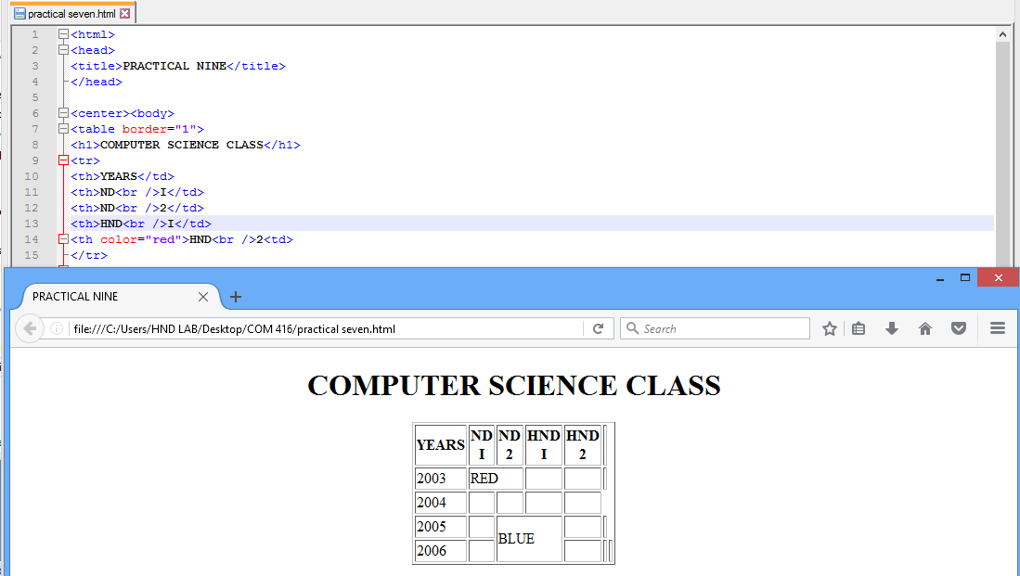

PRACTICAL TEN

